DASHBOARD: -dashboard-overview.jpg
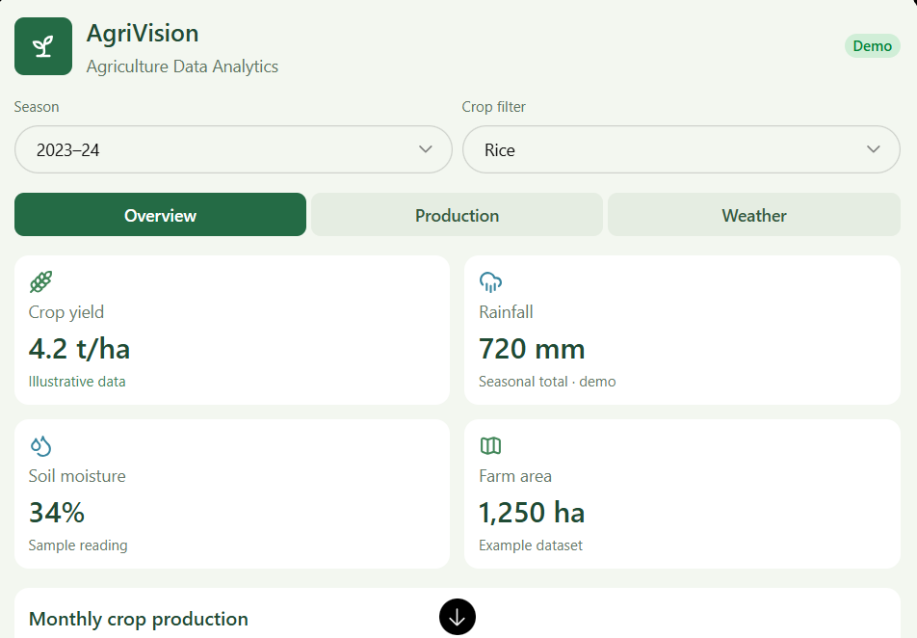
Illustrative production values · tonnes
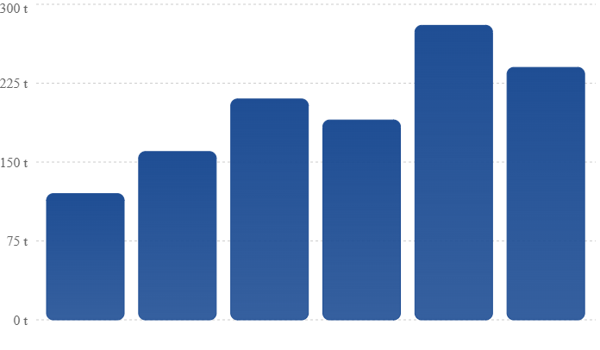
Sample values for dashboard demonstration, not actual agricultural records.
Crop-wise yield comparison
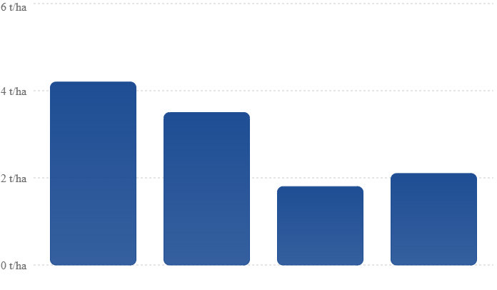
Example yield values in tonnes per hectare.

Types of data in graps:
1. Bar chart — Crop production comparison:
Compare the production of rice, wheat, maize, cotton, and sugarcane.
Data required: Crop name, state, production in tonnes.
Example insight: Which crop has the highest production?

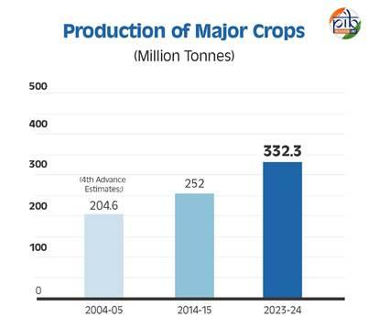
2.line chart: production over time
Show whether agricultural production increases or decreases over several years.
Data required: Year, crop name, annual production.
Example insight: How has rice production changed over time?
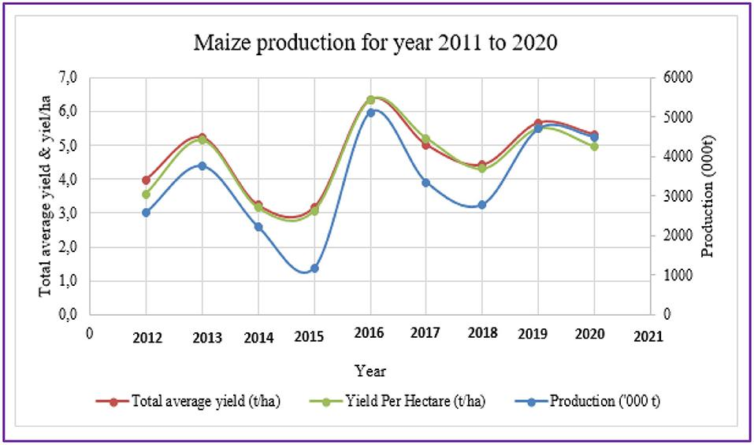

3. Pie chart — Crop production share
Display the proportion of total production contributed by each crop.
Data required: Crop name and production quantity.
Example insight: What percentage of the selected crops is rice?
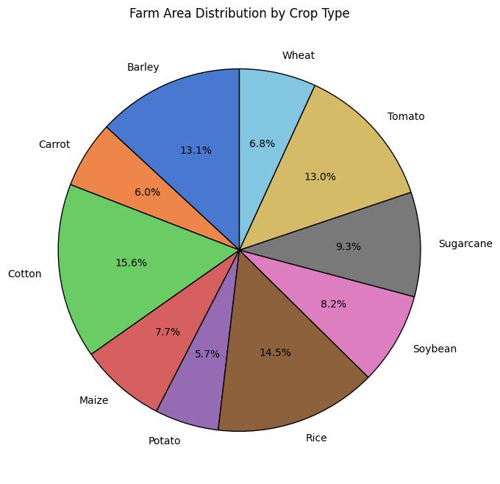

4. Scatter plot — Rainfall and crop yield
Examine the relationship between rainfall and crop yield.
Data required: Rainfall in mm and yield in tonnes per hectare.
Example insight: Do locations with different rainfall levels show different yields?

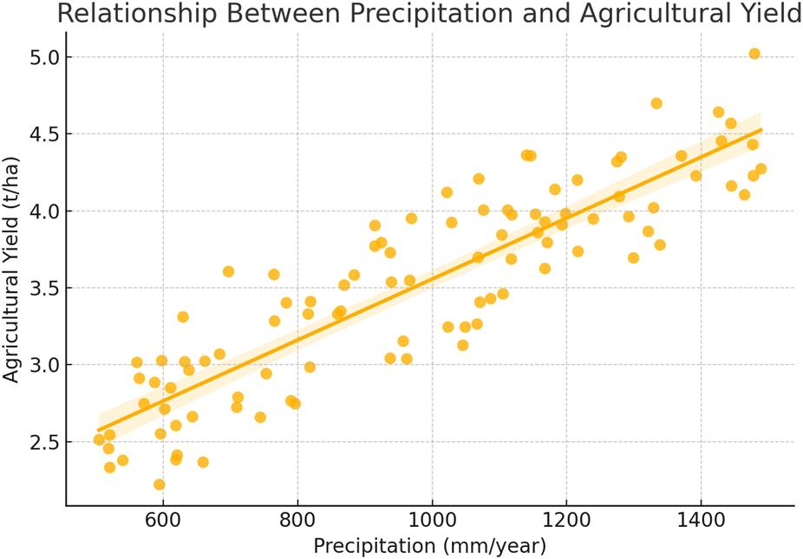

5. Heatmap — Agricultural patterns
Compare rainfall, temperature, soil moisture, or yield across regions and months.
Data required: Region, month, and a numeric measurement.
Example insight: Which months have higher rainfall?

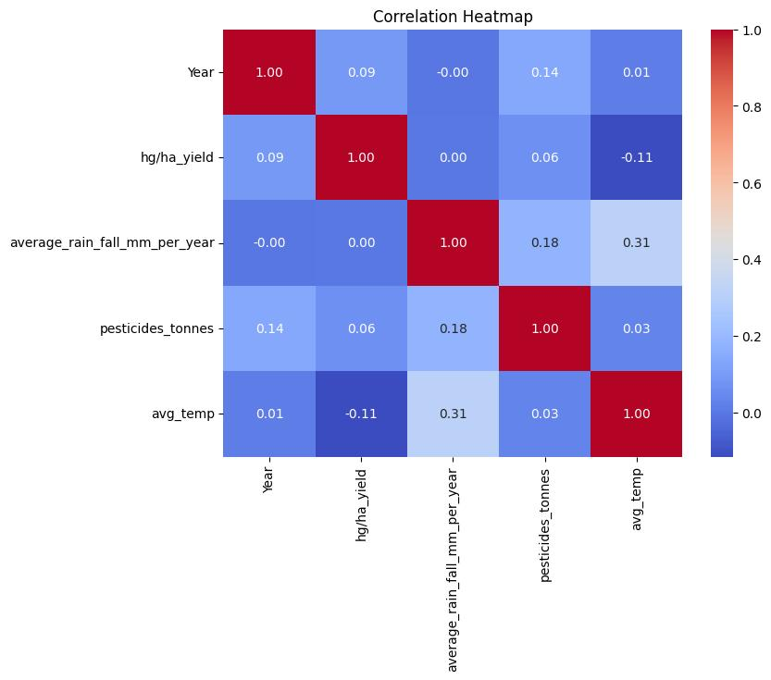

6. Box plot — Yield variation
Compare the spread of crop yields across states or seasons.
Data required: Crop, region, and yield measurements.
Example insight: Which crop has more variation in yield

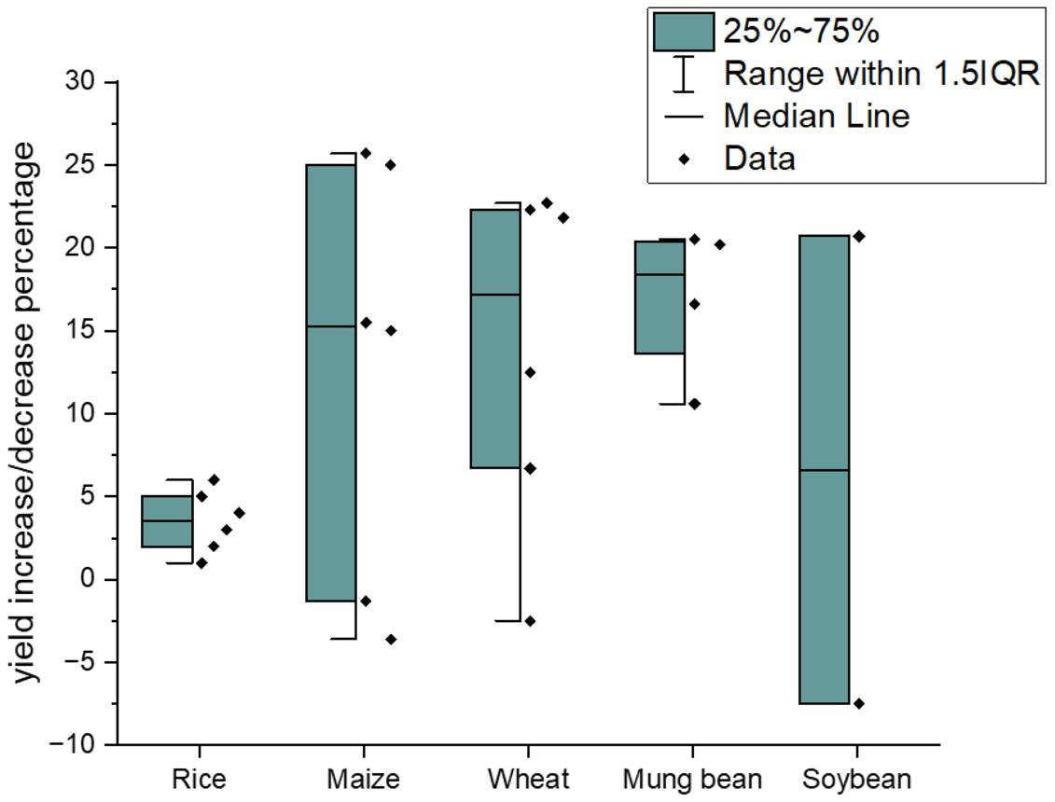

Agricultural dataset with related data
Your project needs a dataset containing columns that can be used to create graphs. You can start with the following sample data.
The values below are illustrative demo data, not verified agricultural statistics. Replace them with real data before drawing conclusions.
State | Crop | Year | Production (tonnes) | Area (hectares) | Rainfall (mm) | Yield (tonnes/ha)
Andhra Pradesh | Rice | 2023 | 12000 | 3000 | 850 | 4.0
Telangana | Rice | 2023 | 10000 | 2500 | 800 | 4.0
Punjab | Wheat | 2023 | 15000 | 3000 | 600 | 5.0
Uttar Pradesh | Wheat | 2023 | 14000 | 3500 | 650 | 4.0
Karnataka | Maize | 2023 | 8000 | 2000 | 700 | 4.0
Maharashtra | Cotton | 2023 | 6000 | 3000 | 750 | 2.0
Tamil Nadu | Rice | 2024 | 13000 | 3000 | 900 | 4.33
Andhra Pradesh | Maize | 2024 | 9000 | 2000 | 780 | 4.5
Telangana | Cotton | 2024 | 6500 | 2500 | 720 | 2.6
Punjab | Wheat | 2024 | 15500 | 3000 | 620 | 5.17

Graph | Required columns
Bar chart | Crop, Production
Line chart | Year, Production
Pie chart | Crop, Production
Scatter plot | Rainfall, Yield
Heatmap | Month, State, Rainfall or Yield
Map | State, Production or Yield
Box plot | Crop, Yield
Stacked bar | State, Crop, Fertilizer type, Quantity
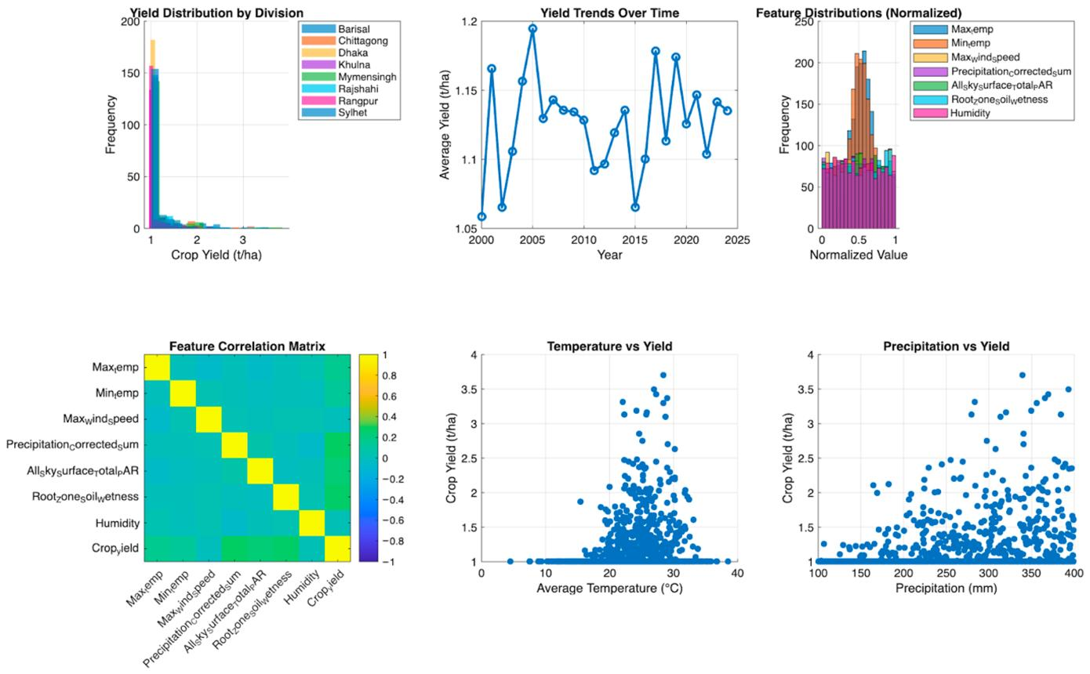

PROGRAM:
rogram

import streamlit as st
import pandas as pd
p
import plotly.express as px

# Page configuration
st.set_page_config(
page_title="Agriculture Dashboard",
page_icon="🌾",
layout="wide"
)

# Title
st.title("🌾 Smart Agriculture Dashboard")
st.write("Agriculture Data Visualization using Streamlit")

# Load dataset
df = pd.read_csv("agriculture.csv")

# Sidebar
st.sidebar.header("🔍 Filters")

states = st.sidebar.multiselect(
"Select State",
df["State"].unique(),
default=df["State"].unique()
)

crops = st.sidebar.multiselect(
"Select Crop",
df["Crop"].unique(),
default=df["Crop"].unique()
)

seasons = st.sidebar.multiselect(
"Select Season",
df["Season"].unique(),
default=df["Season"].unique()
)

# Filter data
filtered_df = df[
(df["State"].isin(states)) &
(df["Crop"].isin(crops)) &
(df["Season"].isin(seasons))
]

# Dashboard metrics
col1, col2, col3, col4 = st.columns(4)

col1.metric(
"🌱 Total Area",
f"{filtered_df['Area_Hectares'].sum():,.0f} ha"
)

col2.metric(
"🌾 Production",
f"{filtered_df['Production_Tonnes'].sum():,.0f} tonnes"
)

col3.metric(
"📈 Average Yield",
f"{filtered_df['Yield_Tonnes_Ha'].mean():.2f}"
)

col4.metric(
"🌧 Average Rainfall",
f"{filtered_df['Rainfall_mm'].mean():.0f} mm"
)

st.divider()

# Chart 1
st.subheader("🌾 Production by Crop")

crop_data = (
filtered_df
.groupby("Crop")["Production_Tonnes"]
.sum()
.reset_index()
)

fig1 = px.bar(
crop_data,
x="Crop",
y="Production_Tonnes",
title="Production by Crop"
)

st.plotly_chart(fig1, use_container_width=True)

# Chart 2
st.subheader("🌧 Rainfall vs Yield")

fig2 = px.scatter(
filtered_df,
x="Rainfall_mm",
y="Yield_Tonnes_Ha",
color="Crop",
hover_data=["State", "District"]
)

st.plotly_chart(fig2, use_container_width=True)

# Chart 3
st.subheader("🌱 Production by Soil Type")

soil_data = (
filtered_df
.groupby("Soil_Type")["Production_Tonnes"]
.sum()
.reset_index()
)

fig3 = px.pie(
soil_data,
names="Soil_Type",
values="Production_Tonnes",
title="Production Distribution by Soil Type"
)

st.plotly_chart(fig3, use_container_width=True)

# Dataset
st.subheader("📋 Agriculture Dataset")
st.dataframe(filtered_df, use_container_width=True)

# Download button
csv = filtered_df.to_csv(index=False)

st.download_button(
"⬇️ Download Data",
csv,
"agriculture_data.csv",
"text/csv"
)

